Group_22 106502531 / 106502532

Description:

1. Initial state.

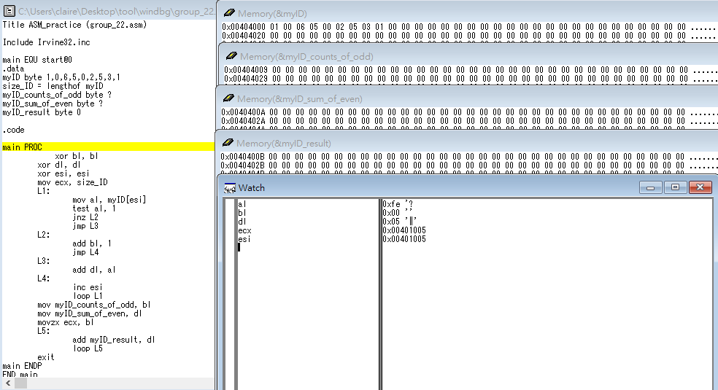

2. bl = 0, dl = 0, esi = 0, ecx = size_ID.

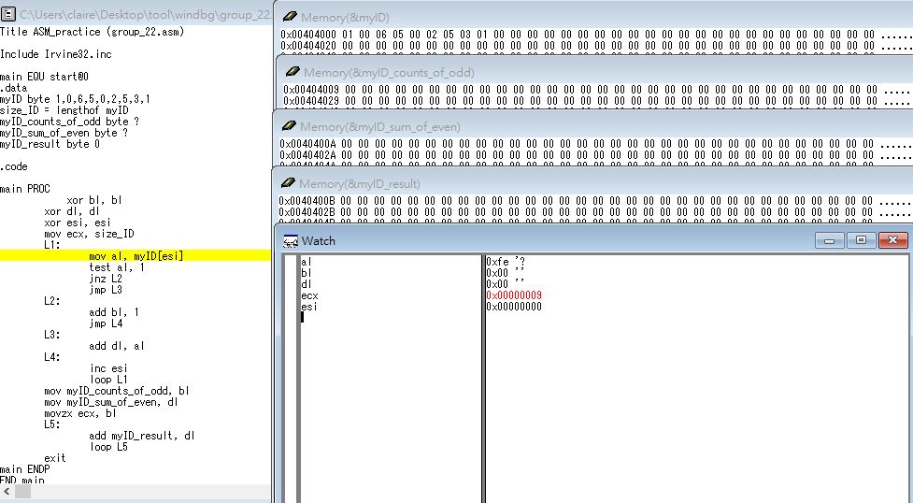

1. Put the value of myID into al. if al is odd then jump to L2,

else if al is even then jump to L3.

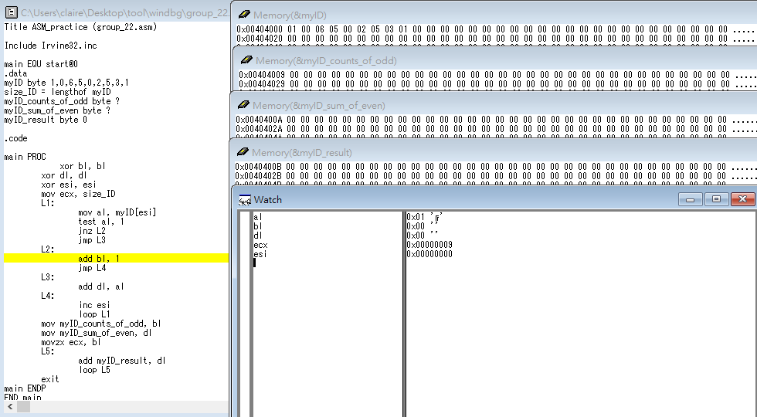

1. al is odd, run L2, bl += 1, and jump to L4.

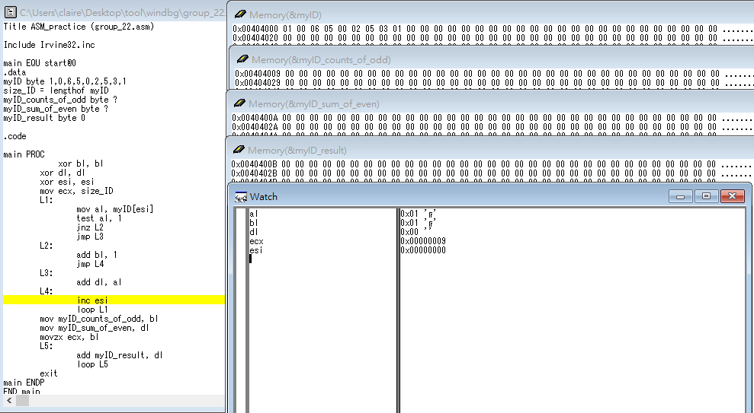

1. al is even, run L3, dl += al.

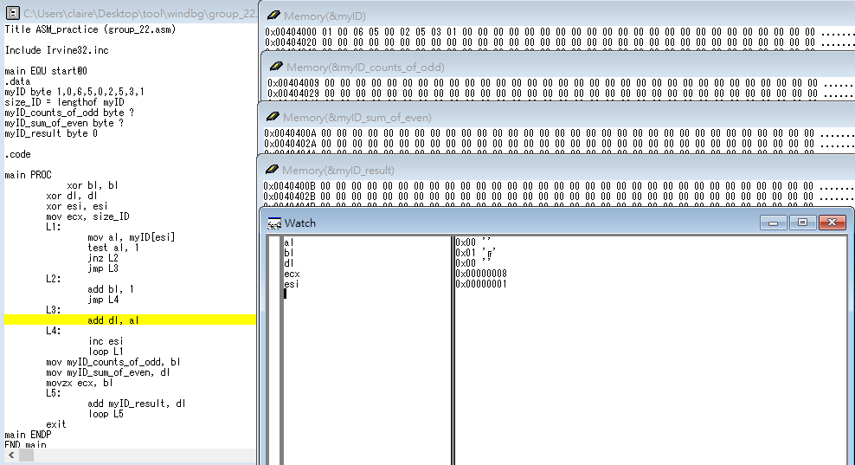

1. loop until ecx is 0.

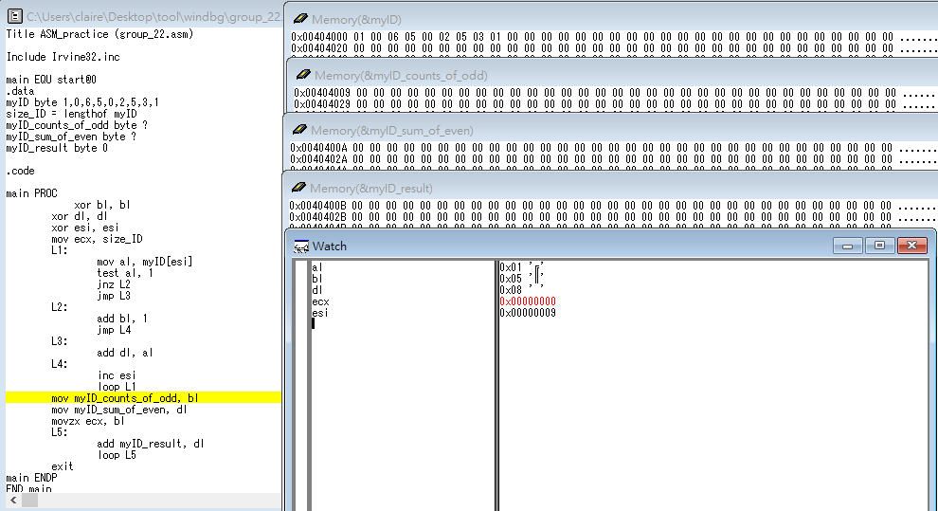

1. Put value of bl into myID_counts_of_odd,

Put value of dl into myID_sum_of_even.

Put value of bl into ecx.

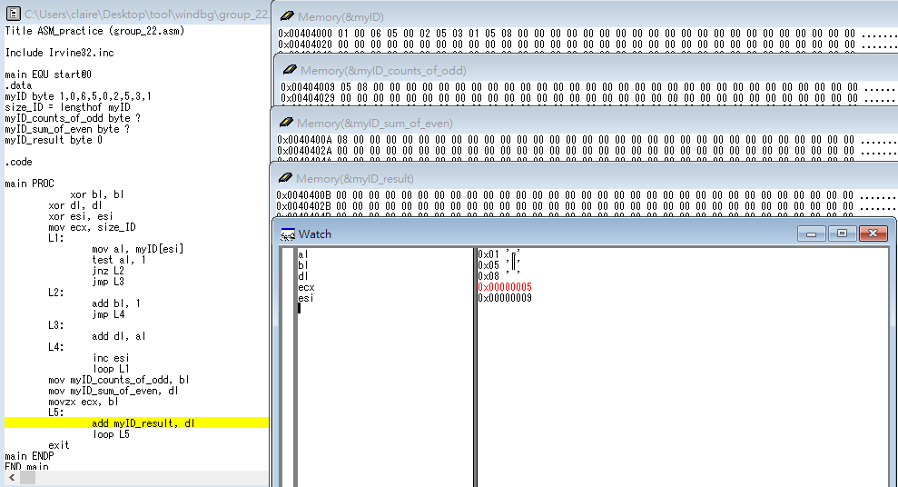

1. myID_result += dl, and loop until ecx is 0(bl*dl).

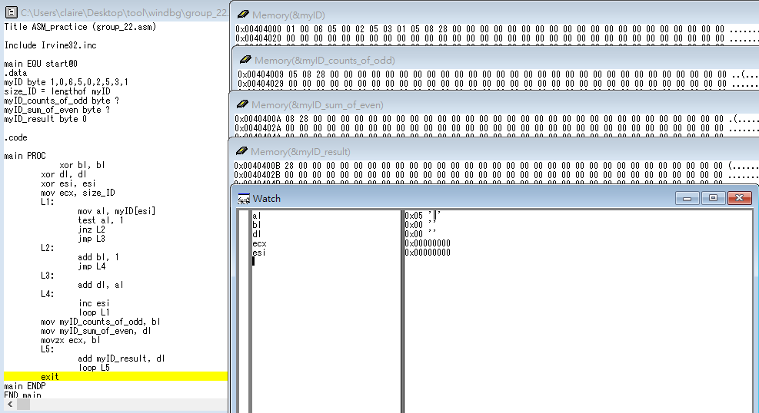

(myID_result is hexadecimal.)

Review:

Today, we learned some instructions about conditional processing and apply them. For instance, And, Or, Xor, Not instruction.

Also, we learned Test and Cmp instructions. It’s more difficult to understand. We should spend more time studying it.